Module 1: Understanding the Benefits of Containers

1. Introduction to Containers
   1. Container
      1. Definition: standard unit of software that encapsulates everything that programmers need to build, ship, and run applications
      2. Allows swift transition from physical to virtual, from private cloud to public cloud and seemlesly transition
   2. Why use containers:
      1. 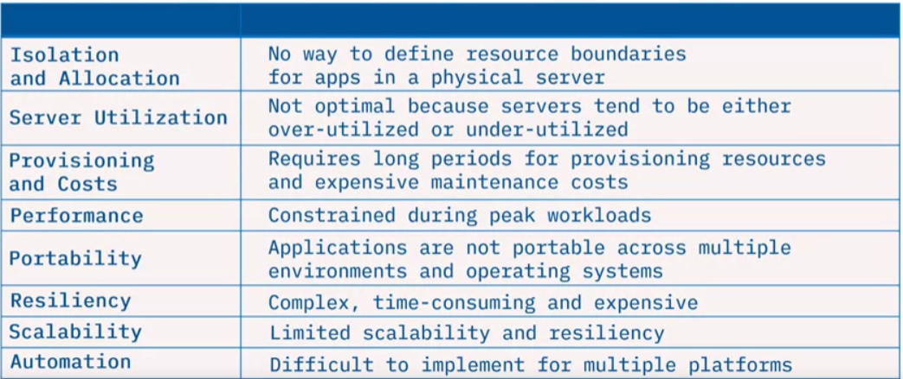
   3. Container Characteristics:
      1. 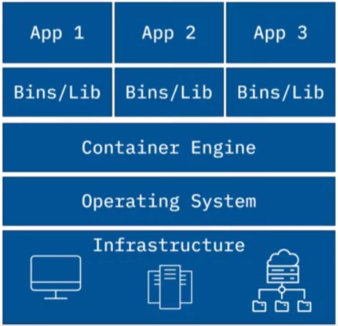
      2. Virtualizes the operating system
      3. Light-weight, fast, isolated, portable, and secure
      4. Requires less memory space
      5. Binaries, libraries within container enable apps to run
      6. One machine can host multiple containers
      7. Platform independent and coding language independent
   4. Benefits:
      1. Quickly create applications using automation
      2. Lower deployment time and costs
      3. Improve resourece utilization (CPU, memory)
      4. Support next-gen applications (microservices)
   5. Challenges
      1. Security can be impacted if operating system affected
      2. Difficult to manage thousands of containers
      3. Complex to migrate legacy projects to container technology
      4. Difficult to right-size containers for specific scenarios
   6. Venders:
      1. 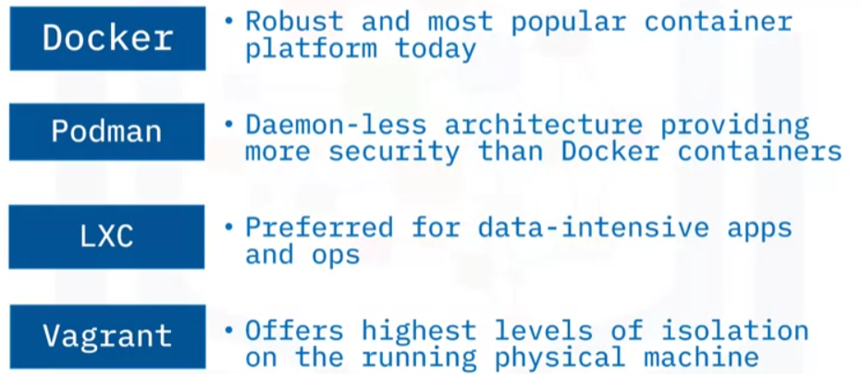
2. Introduction to Docker
   1. Definition – open platform for developing, running, and shipping applications
   2. Docker process

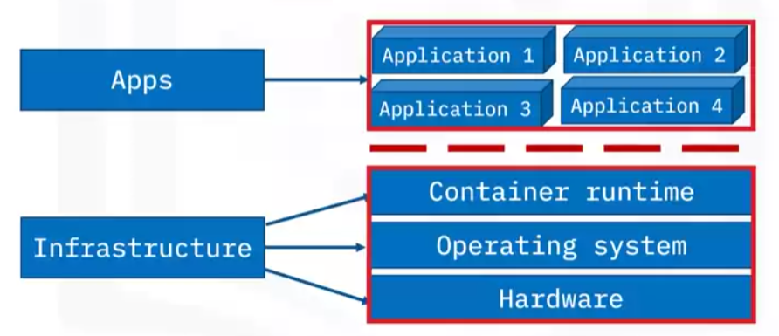

* 1. Underlying technology
     1. Written in Go programming language
     2. Uses Linux kernel features to deliver functionality
     3. Uses the namespaces technology to provide an isolated workspace called “container”
     4. Creates a set of namespaces for every container and each aspect runs in a separate namespace with access limited to that namespace
  2. Add-ons
     1. Complementary tools, i.e.: docker cli, docker compose, prometheus
     2. Orchestration Technologies: kubernetes, docker swarm
     3. Development methodologies: using microservers and serverless
  3. Benefits of Docker Containers
     1. Consistent and isolated environments
     2. Fast deployment
     3. Repeatability and automation
     4. Supports Agile and CI/CD DevOps practices
     5. Versioning for easy testing, rollbacks, and redeployments
     6. Collaboration, modulatiry, and scaling
     7. Easy portability and flexibility
  4. Challenging Use Cases; Not a good fit for:
     1. Requiring high performance or security
     2. Based on Monolith architecture
     3. Using rich GUI features
     4. Performing standard desktop or limited functions

1. Building and Running Container Images
   1. Steps to Create and Run Containers
      1. Create a Dockerfile
      2. Use the Dockerfile to create a container image
      3. Use the container image to create a running container
   2. Dockerfile example:
      1. 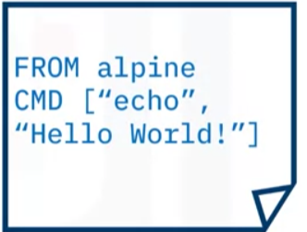
   3. Build command:
      1. 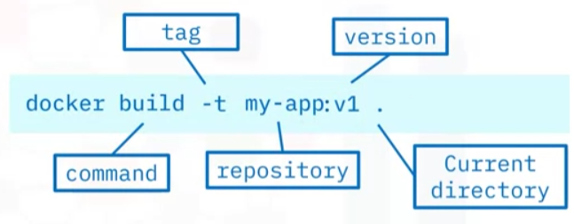
      2. 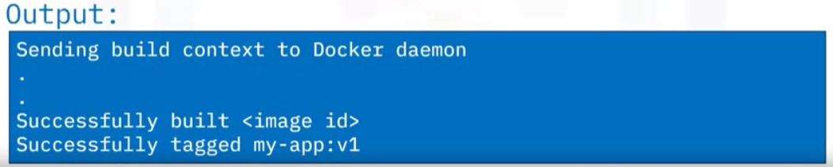
   4. To verify, run:
      1. 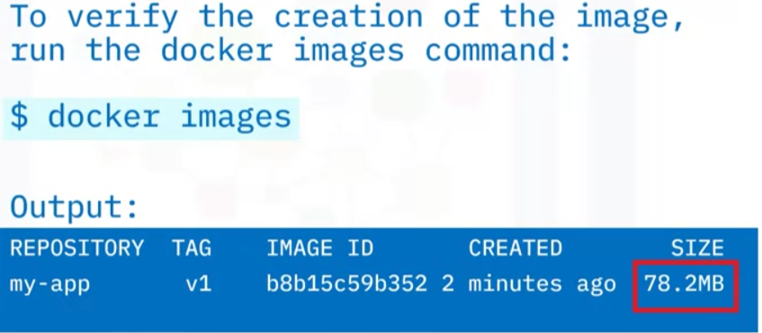
   5. Docker run command:
      1. 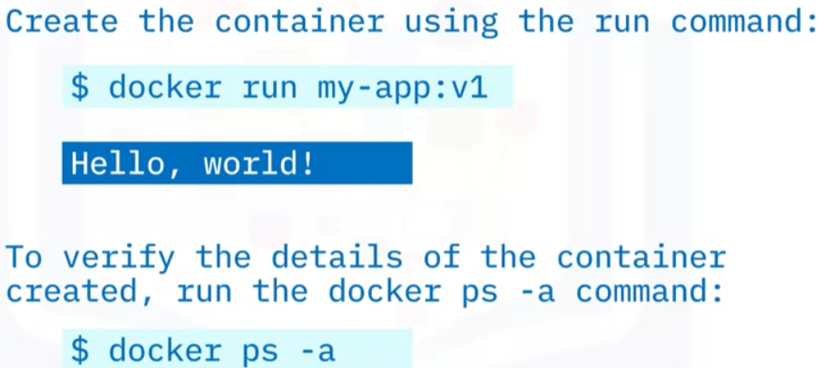
   6. Commands Cheat Sheet
      1. 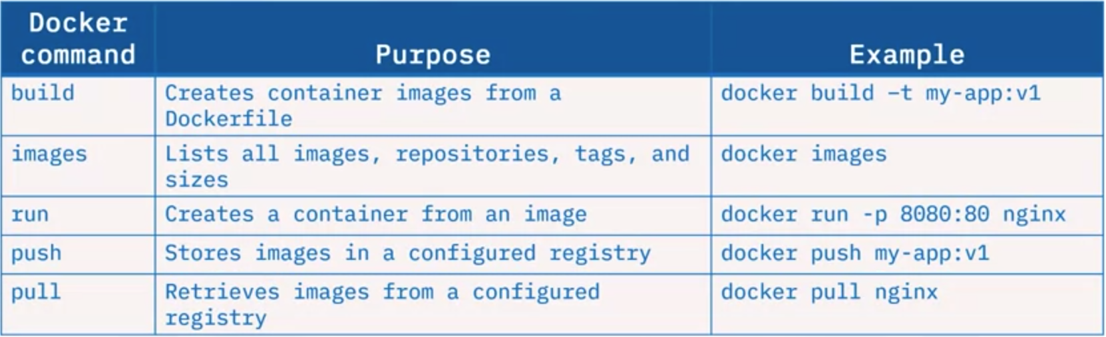
2. Docker Objects
   1. 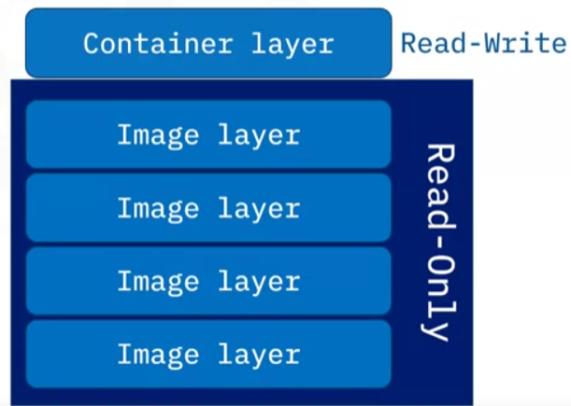
   2. Dockerfile
      1. Is a text file that contains instructions needed to create an image
      2. Is created using any editor from the console or terminal
   3. Instructions that Docker Provides
      1. FROM - Defines base image
      2. RUN - Executes arbitrary commands
      3. CMD - Defines default command for container execution
   4. Docker image
      1. Read only template with instructions for creating Docker container
      2. Build using instructions in a Dockerfile; a new read-only image layer is created for each instruction
      3. A writeable layer is added when an i9mage is run as a container
      4. Layers can be shared between images which saves disk space and network bandwidth
   5. Container image naming
      1. hostname/repository:tag
      2. example: docker.io/ubuntu:18.04
   6. Docker container
      1. Runnable instance of an image
      2. Can be created, stopped, started, or deleted using the Docker API or CLI
      3. Can connect to multiple networks, attach storage, or create a new image based on its current state
      4. Is well isolated from other containers and its host machine
   7. 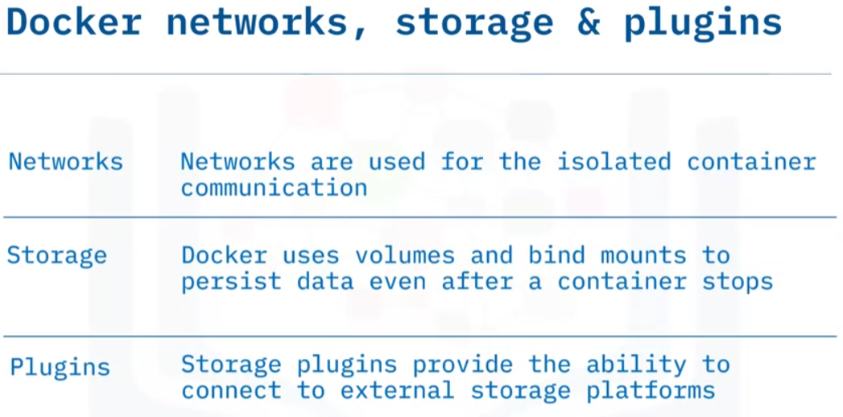
3. Docker Architecture
   1. Based on client-server architecture
   2. Provides a complete application environment
   3. Includes the client, the host, and the registry components
   4. Process Overview
      1. Using either CLI or REST APIs, the Docker Client sends instructions or commands to the Docker host server
         1. Note: REST (Representational State Transfer) is an architectural style that streamlines communication between computer systems on the web
      2. Docker Host server, referred to as the host, included Docker daemon known as dockerd
      3. The daemon listens for Docker API requests or commands such as “docker run” and processes those commands
      4. The daemon builds, runs, and distributes containers to the registry
      5. The registry stores the images
   5. 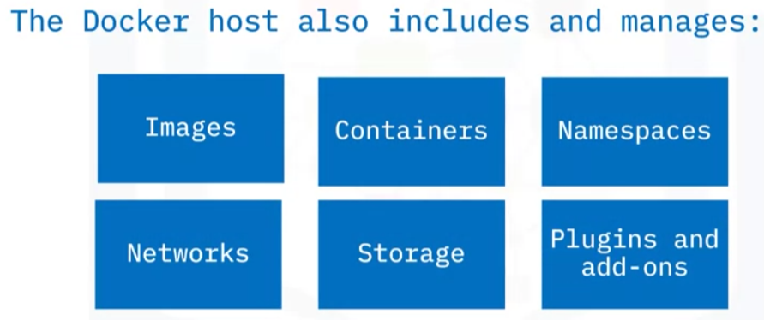
   6. Docker communication:
      1. Docker client can communicate with both local and remote hosts
      2. Docker client and host daemon can run:
         1. On the same system
         2. On different systems
      3. Daemons can also communicate with other daemons to manage Docker services
   7. Docker stores and distributes images in Registry
      1. Access is either
         1. Public: such as Docker Hub – everyone can access
         2. Private: implemented for security
      2. Registry locations are either hosted or self-hosted
      3. 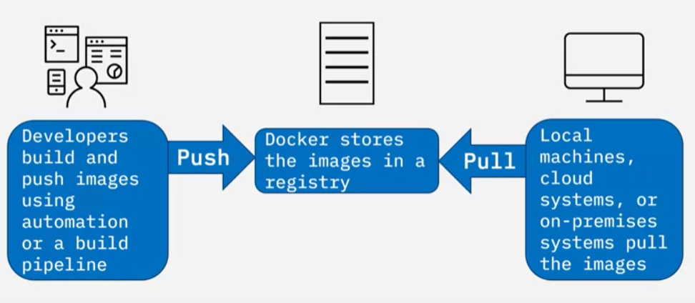
   8. Docker Architecture
   9. 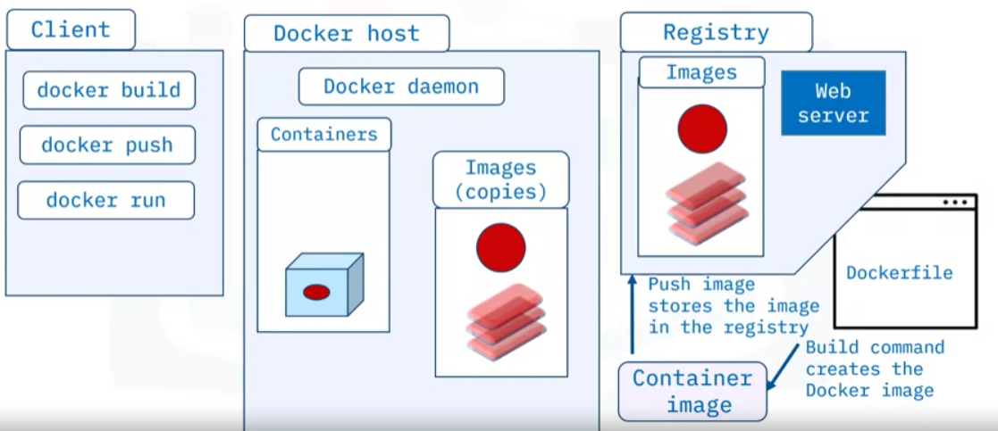

Module 2: Container Orchestration

1. Container Orchestration
   1. How to manage upscaling to a large number containers
   2. Definition: container orchestration is a process that automates the container lifecycle of containerized applications
   3. Lifecycle:
      1. Deployment
      2. Management
      3. Scaling
      4. Networking
      5. Availability
   4. Orchestration automates lifecycle by:
      1. Steamlining complexity
      2. Enabling hands-off deployment and scaling
      3. Increases speed, agility, and efficiency
      4. Seamlessly integrates into CI/CD workflows
      5. Allow development teams to use resources more efficiently
   5. Orchestration Features:
      1. Defines container images and registry
      2. Improves provisioning and deployment
      3. Secures network connectivity
      4. Ensures availability and performance
      5. Manages scaling and load balancing
      6. Resource allocation and scheduling
      7. Rolling updates and rollbacks
      8. Health checks and automated error handling
   6. How does orchestration work?
      1. Specified by config files:
         1. YAML or JSON configure containers to:
            1. Find resources
            2. Establish a Network
            3. Store Logs
      2. Deployment Scheduling
         1. Automatically schedules new container deployment
         2. Finds the right host based on predefined settings or restrictions
      3. Manages Container Lifecycle
         1. Configuration file specs inform:
            1. System parameters (CPU procs, memory)
            2. File Parameters (file metadata, proximity)
      4. Scaling and Productivity: Automation is used to:
         1. Maintain productivity
         2. Support Scaling
   7. Well known orchestration tools
      1. Marathon
         1. Open source cluster manager
         2. Scales container infrastructure by automating management and task monitoring
      2. Nomad
         1. Free, open-source cluster management and scheduling tool
         2. Support various app types on all major operating systems
      3. Docker Swarm
         1. Open-source container orchestration platform
         2. Automates deployment of containerized apps
      4. Kubernetes
         1. Standard for open-source container orchestration platforms
         2. Robust feature set, broadly supported
   8. Benefits of container orchestration
      1. Increased production
      2. Faster deployment
      3. Reduced Costs
      4. Stronger Security
      5. Easier Scaling
      6. Faster Recovery (From failures)
2. Introduction to Kubernetes
   1. Definition: Open-source system for automating deployment, scaling, and management of containerized applications
   2. What it is:
      1. Open source containerization orchestration platform
      2. Easily portable across clouds and on-premises
      3. Includes a growing exosystem of projects, products, and partners
      4. Facilittates declarative management
   3. What it is not:
      1. A traditional all-inclusive platform as a service (PaaS)
      2. A rigid or opinionated system that does not support a diverse variety of workloads and containerized applications
      3. Provide continuous integration/ continuous delivery pipelines to deploy source code or build applications
      4. Prescribe logging, monitoring, or alerting solutions
      5. Provide built-in middleware, databases, or other services
   4. Concepts
      1. 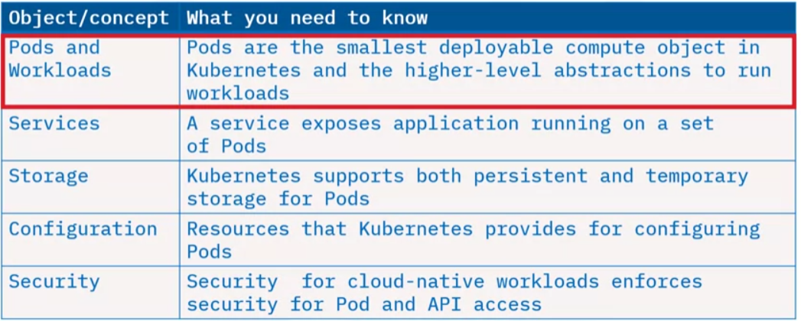
      2. 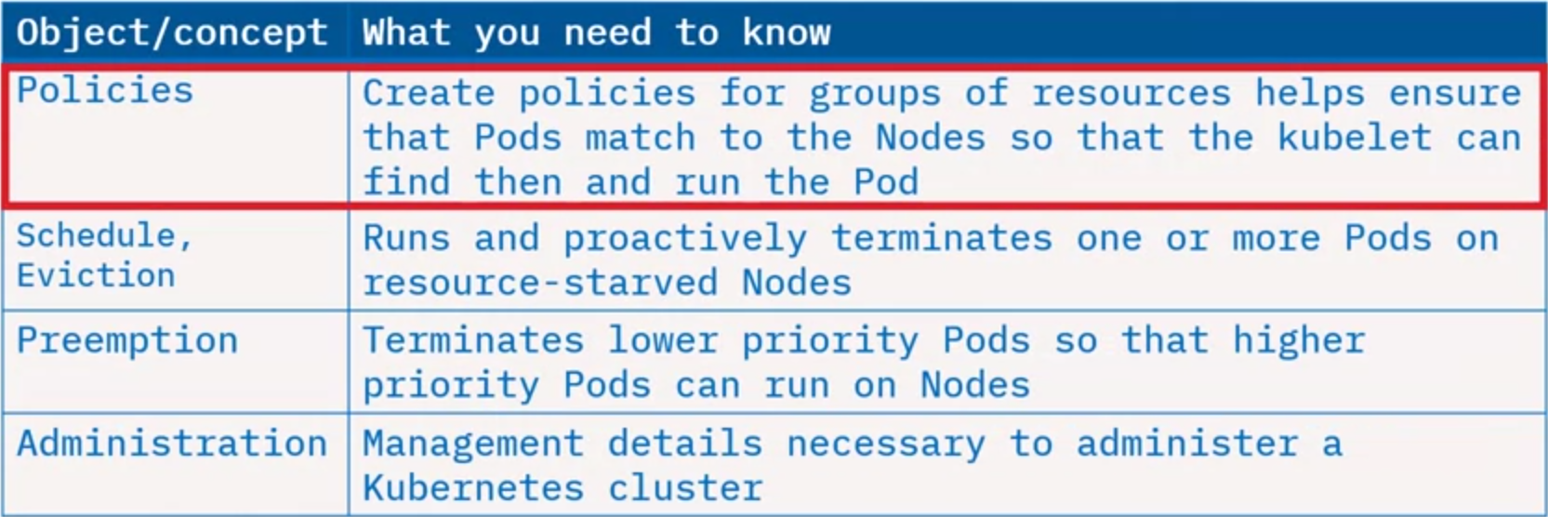
      3. Note: Each pod has unique IP address; sets of pods have single DNS name
   5. Capabilities
      1. Automated rollouts and rollbacks
         1. Progressively rolls out changes to application or configuration
         2. Monitors application health and ensures instances are running
         3. Rolls back changes
      2. Storage Orchestration
         1. Automatically mounts your chosen storage system whether from local storage, network storage, or public cloud
      3. Horizontal Scaling
         1. Scales loads automatically based on metrics or via commands
      4. Automated bin packing
         1. Increases resource utilization and cost savings using a mix of critical and best-effort workloads
         2. Performs container auto-placement based on resource requirements and conditions without sacrificing high availability (HA)
      5. Secret and Configuration Management
         1. Stores and manages sensisitive information (credentials, keys or tokens) securely
         2. Deploys and updates secrets and configuration without rebuilding images
      6. Ipv4/Ipv6 dual-stack
         1. Assigns both Ipv4 and Ipv6 addresses to Pods and Services
      7. Batch execution
         1. Manages batch and continuous integration workloads and replaces failed containers, if configured
      8. Self-healing
         1. Restarts, replaces, reschedules, and kills failing or unresponsive containers
         2. Exposes containers to clients only if healthy and running
      9. Service Discovery and load balancing
         1. Discovers Pods using their own IP addresses or a single DNS name
         2. Load-balances traffic across Pods for better performance and high availability
      10. Designed for extensibility
          1. Easily extensible by adding or providing additional features to your Kubernetes cluster without any source code modifications
   6. Kubernetes Ecosystem
      1. 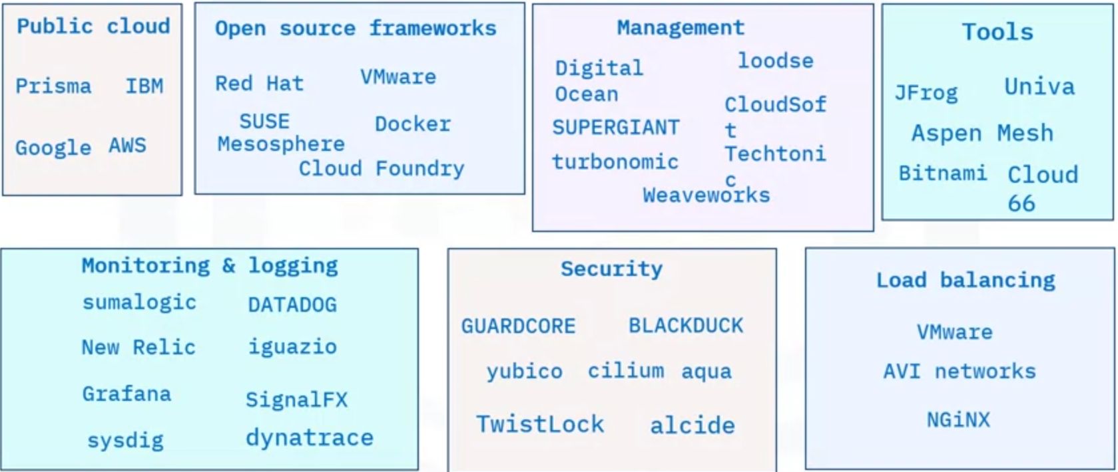
      2. Contains services, support, and tools that are widely available
      3. Running containerized applications requires separate tools in addition to the Kubernetes orchestration tool
      4. Provides additional Kubernetes services
         1. Building container images
         2. Storing images in a container registry
         3. Application logging and monitoring
         4. Continuous improvement and continuous delivery CI/CD
3. Kubernetes Architecture
   1. Kubernetes Control Plane
      1. 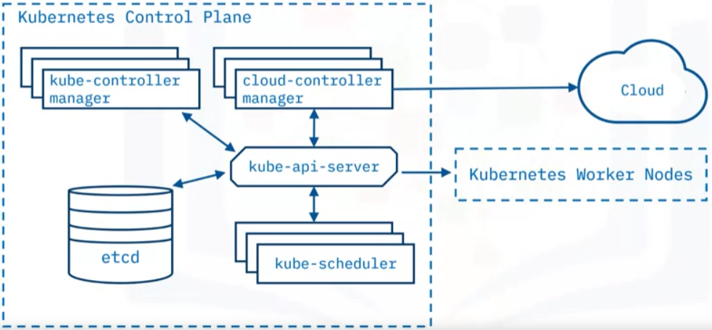
      2. A deployment of Kubernetes is called a Kubernetes Cluster
      3. Each cluster has one master node (the control plane) and one or more worker nodes
      4. Control plane maintains the intended cluster state by making decisions about the cluster and detecting and responding to events ion the cluster
      5. As an analogy it is similar to a thermostat; specify the desired temperature and it regulates heating and cooling systems continuously to maintain the set temp.
      6. Here, as examples:
         1. Decision made by control plane: scheduling of workloads
         2. Responding to an event: creating new resources when an application is deployed
   2. Kubernetes Worker Nodes:
      1. 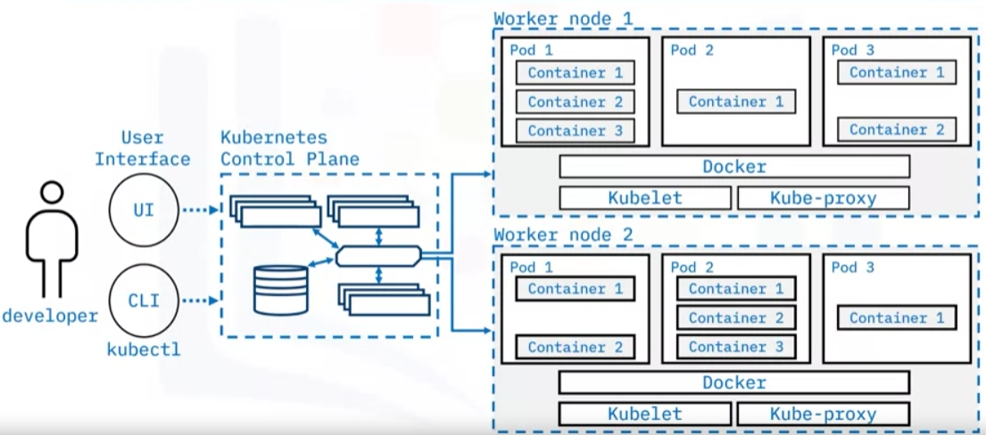
      2. Nodes are worker machines in a Kubernetes cluster
      3. Nodes are not created by Kubernetes itself, but by the cloud provider
      4. This allows Kubernetes to run on a variety of infrastructures
      5. Nodes are then managed by the control plane
   3. Kubernetes API server
      1. 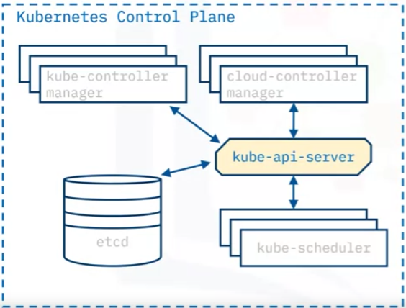
      2. Exposes the Kubernetes API
      3. Front-end for the control plane
      4. All communication in the cluster utilizes this API
      5. The main implementation of a Kubernetes API server is kube-apiserver which is designed to scale horizontally and balance traffic between them
      6. Can run multiple instances of kube-apiserver and balance traffic between those instances
   4. etcd
      1. 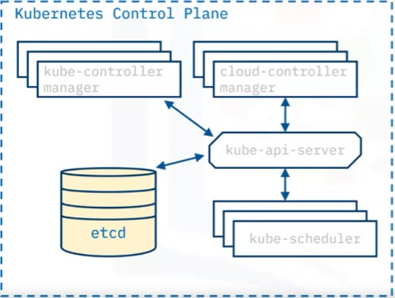
      2. Highly available distributed key-value store that contains all cluster data
      3. Stores deployment configuration data, the desired state, and meta data in a way that can be accessed in a common location
   5. Kubernetes Scheduler
      1. 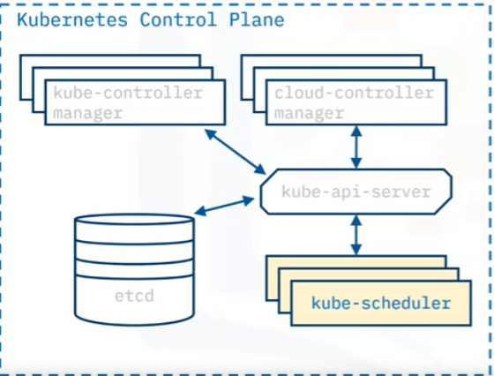
      2. Assigns newly created Pods to nodes (kube-scheduler determines where your workloads should run within cluster)
      3. Selects optimal node according to Kubernetes scheduling principles, configuration options, and available resources
   6. Controller Manager
      1. 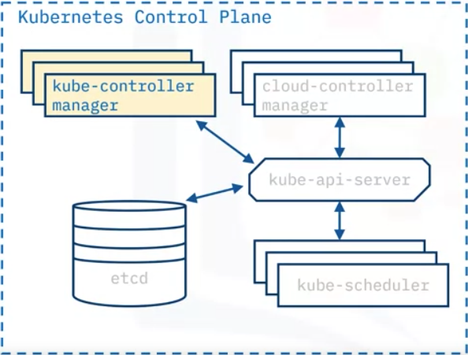
      2. Runs controller processes that monitor the cluster state
      3. Runs controller processes that ensure the actual state matches the desired state
   7. Cloud controller manager
      1. 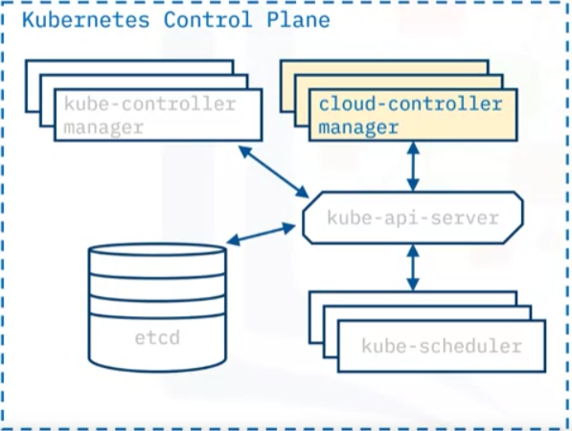
      2. Runs controllers that interact with underlying cloud providers
      3. Links clusters into a cloud provider’s API (strives to be as cloud agnostic as possible)
   8. Nodes
      1. 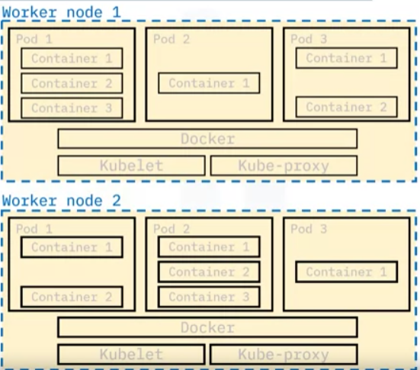
      2. Worker machines in Kubernetes
      3. May be virtual or physical machine
      4. Managed by control plane
      5. Contain the services necessary to run applications
      6. Nodes include pods whicha re the smallest deployment unit in Kubernetes
      7. Pods include one or more containers; containers share all the resources of the node and can communicate among themselves
   9. Kubelet
      1. 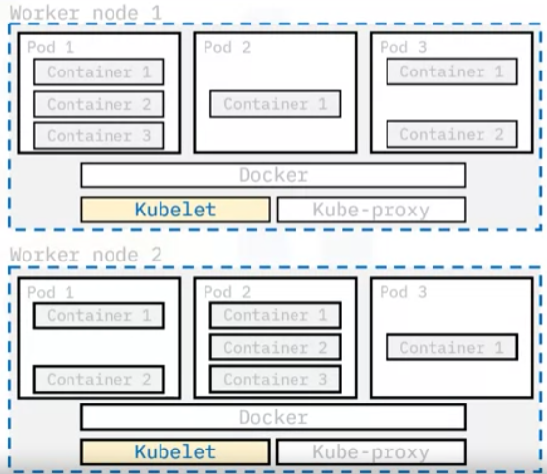
      2. Most important unit of worker node
      3. Communicates with the API server
      4. Ensure that Pods and their associated containers are running
      5. Reports to the control plane on the pods’ health and status
      6. To start a pod the Kubelet uses the containers runtime
   10. Container runtime
       1. 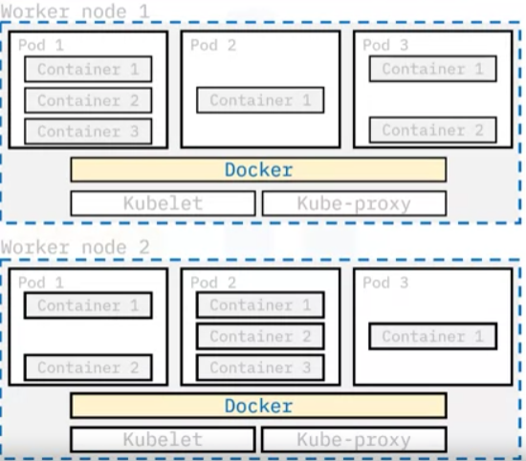
       2. Downloads images and runs containers
       3. Kubernetes implements an interface so that this component is pluggable
       4. Docker is a well-known runtime; others include Podman and Cri-o
   11. Kubernetes Proxy
       1. 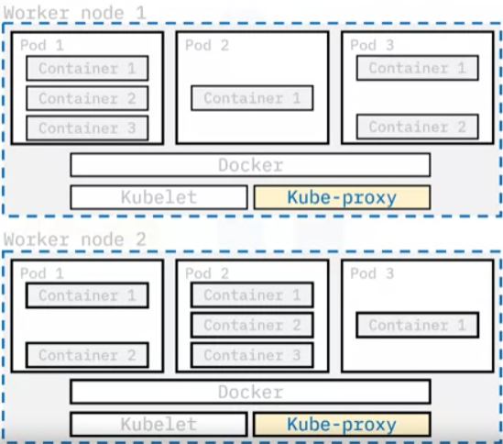
       2. Network proxy that runs on each node in a cluster
       3. Maintains network rules that allow communication to Pods running on nodes; i.e. communication to workloads running on your cluster
       4. Can come from within or outside cluster
4. Kubernetes Objects
   1. Part 1
      1. Key Terms:
         1. Object: a bundle of software data that has an identity, a state, and a behavior. Examples Include:
            1. Variables
            2. data structures
            3. specific functions
         2. Entity: a person place or thing with an identity and associated data
            1. Ex: customer account in banking
         3. Persistent: something which lasts, despire server failures/ network attacks
            1. Ex: persistent storage
      2. What are Kubernetes Objects
         1. Persistent entities
         2. Examples:
            1. Pods
            2. Namespaces
            3. ReplicaSets
            4. Deployments
         3. Consists of 2 main fields:
            1. Object Spec

Provided by user

Defines desired state

* + - * 1. Status

Provided by Kubernetes

Defines current state

* + - 1. To work with Kubernetes objects, use the Kubernetes API directly with the client libraries, the kubectl command-line interface, or both
    1. Labels and Selectors:
       1. Labels are key/value pairs attached to objects
          1. Intended for identification of objects
          2. Not unique
          3. Helps organize and group objects
       2. Selectors are core grouping method in Kubernetes: Identifies and groups a set of objects
    2. Namespaces and names
       1. Namespaces provide a mechanism for isolating groups of resources within a single cluster
          1. Segregate cluster by team, project, etc
          2. Necessary with larger numbers of users
          3. There may be only one namespace for a user who works with one team which only has one project that is deployed into a cluster. Alternatively, there may be many teams or projects, or a lot of users with different needs, where additional namespaces may be created.
          4. Provide a scope for object names:

Each object has a name

Names are unique for a resource type within a namespace

* + 1. Pods
       1. 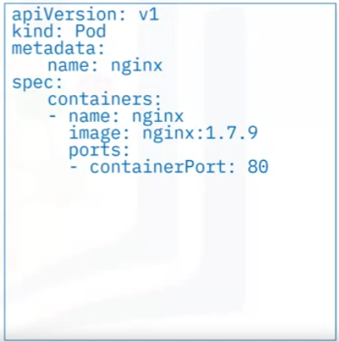
       2. Simplest unit in Kubernetes
       3. Represents processes running in your cluster
       4. Encapsulates one or more containers
       5. Replicating a Pod serves to scale applications horizontally
       6. Yml files often used to define pod
       7. Fields:
          1. kind: specifies the kind of object to be created (here it’s a Pod)
          2. spec: provides the appropriate fields for an object to be created; such as containers that will run in this Pod.

Container: A PodSpec must contain at least one container

(here, it is named “nginx”)

Image: dictates which image will run in the Pod

Ports: array lists the ports that the container exposes

* + 1. ReplicaSet
       1. 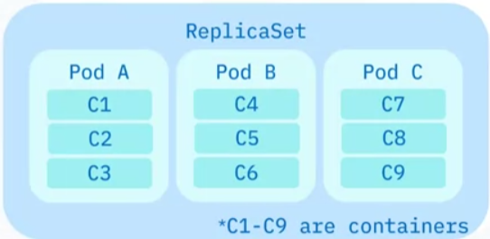
       2. Set of horizontally scaled running Pods
       3. Configuration File
          1. 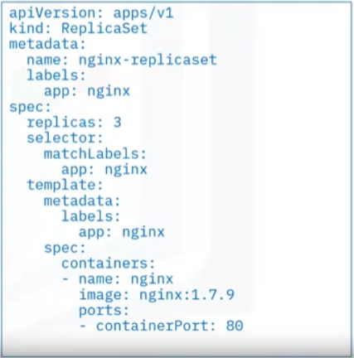
          2. Defines:

Replicas: Number of replicas (that should be running at a given time)

Template: Pod Template

Defines the pods that should be created by the ReplicaSet

Selector: can be used to identify which Pods it can acquire

matchLabels: specifies the Pods that can be acquired by the ReplicaSet

app: notice that the app field is the same as the label of the in the Pod template

* + - * 1. Generally encapsulated by a Deployment (higher level concept which manages ReplicaSets)
    1. Deployment
       1. Higher-level object that provides updates for Pods and ReplicaSets
       2. Run multiple replicas of an application using ReplicaSets
       3. Suitable for stateless applications; for stateful applications, Stateful Sets are used
       4. Examples:
          1. Deployment of a replicatied application
          2. Pod updates managed by a Deployment
          3. Scaling up of an application
       5. Specification Example:
          1. 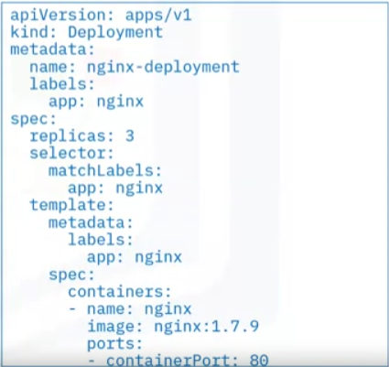
          2. Kind: Deployment
          3. Replicas: defines # of replicas
          4. Selector: defines which pods can be acquired
          5. Pod template
       6. Update triggers a rollout; scales up or down to target # of replicas
  1. Part 2
     1. Service
        1. 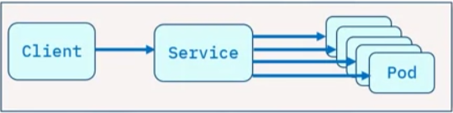
        2. Description/Definition:
           1. REST object, like Pods

Note: REST (Representational State Transfer) is an architectural style that streamlines communication between computer systems on the web

* + - * 1. Logical abstraction for a set of Pods in a cluster
        2. Provides policies for accessing the Pods and cluster
        3. Acts as a load balancer across the Pods
        4. Is assigned a unique IP address for accessing application deployed on Pods
        5. Eliminates the need for a separate Service discovery process
      1. Properties
         1. Supports multiple protocols such as TCP (default), UDP, and others
         2. Supports multiple port definitions

Port number with the same name can very in each backend Pod

* + - * 1. Can have optional selector
        2. Optionally maps incoming ports to a targetPort
      1. Why is it needed?
         1. Pods in a cluster are volatile (can be destroyed or created over time)
         2. This volatility leads to discoverability issues because of changing IP addresses
         3. A Service keeps track of the changes and exposes a single IP address or a DNS name
         4. Utilizes selectors to target a set of Pods
         5. Native Kubernetes applications:

Update API endpoints when there are changes in the Pods of a service

* + - * 1. Non-native Applications:

Use a virtual-IP-based bridge or load balancer between the applications and the backend Pods

* + - 1. Types of Services:
         1. ClusterIP

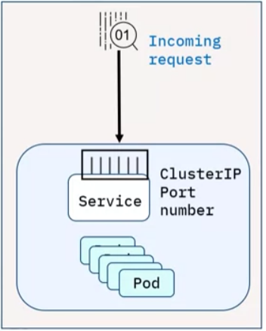

Default and most common service type

Assigned a cluster-internal IP address to the ClusterIP Service that makes the Service only reachable within the cluster

Cannot make requests to Service (Pods) outside the cluster

Can set ClusterIP address in the Service definition file

Provides interservice communication within the cluster

* + - * 1. NodePort

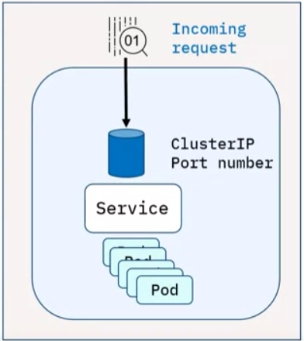

Extension of ClusterIP Service

Creates and routes the incoming requests automatically to the ClusterIP Service

Exposes the Service on each Node’s IP address at a static port (Note: for security purposes, production use is not recommended)

Exposes a single Service with no load-balancing requirements for multiple services

* + - * 1. LoadBalancer: External Load Balancer (ELB)

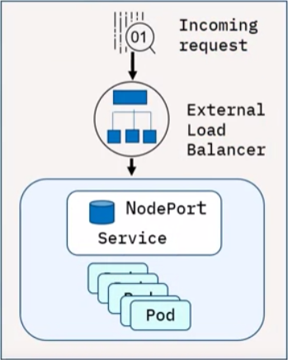

Extension of the NodePort Service, an ELB creates NodePort and ClusterIP Services automatically

Integrates and automatically directs traffic to the NodePort Service with a cloud provider’s ELB

To expose a Service to the Internet you need a new ELB with an IP address

Can use a cloud provider’s ELB to host your cluster

* + - * 1. External Name

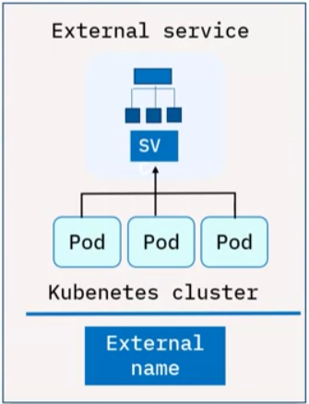

Maps to a DNS name and not to any selector

Requires a ‘spec.externalName’ parameter

Maps the Service to contents of the externalName field that returns a CNAME record and its value

Used to create a Service that represents an external storage and enable Pods from different namespaces to talk to each other

* + - 1. Ingress
         1. 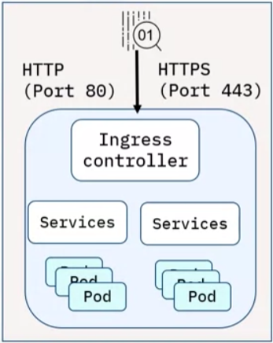
         2. API object (combined with a controller) that provides routing rules to manage external users’ access to multiple Services in a Kubernetes cluster
         3. In production, Ingress exposes applications to the Internet via port 80 (HTTP) or port 443 (HTTPS)
         4. An ELB is expensive and is managed outside the cluster
      2. DaemonSet
         1. 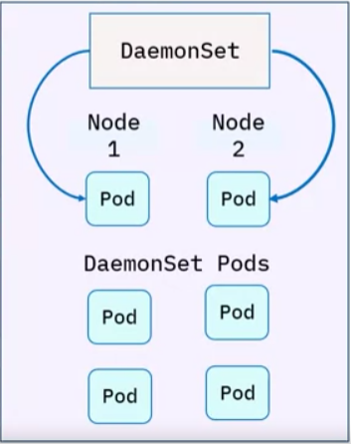
         2. An object that makes sure that Nodes run a copy of a Pod
         3. As nodes are added to a cluster, Pods are added to the Nodes
         4. Pods are garbage collected when removed from a cluster
         5. If you delete a DaemonSet, all Pods are removed
         6. Ideally used for storage, logs, and monitoring Nodes
      3. StatefulSet
         1. 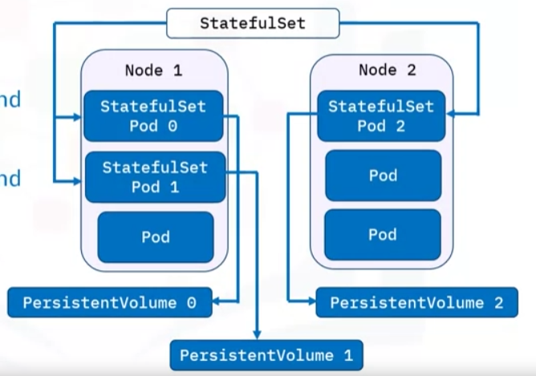
         2. Object that manages stateful applications
         3. Manages deployment and scaling of Pods
         4. Provides guarantees about the ordering and uniqueness of Pods
         5. Maintains a sticky identity for each of your Pods
         6. Provides persistent storage columes for your workloads
      4. Job
         1. Object that creates Pods and tracks its completion process
         2. Jobs are retried until completed
         3. Deleting a Job will remove the created Pods
         4. Suspending a Job will delete its active Pods until the Job resumes
         5. A Job can run several Pods in parallel
         6. A CronJob is regularly used to create Jobs on an iterative schedule
    1. Review:
       1. A service in Kubernetes is a REST object that provides policies for accessing the pods and cluster.
       2. ClusterIP is the default and most common Service type and provides Inter-service communication within the cluster
       3. An extension of ClusterIP Service, a NodePort Service, creates and routes the incoming requests automatically to the ClusterIP Service.
       4. An extension of the NodePort Service, an External Load Balancer creates NodePort and ClusterIP Services automatically.
       5. Ingress is an API object that, when combined with a controller, provides routing rules to manage external users' access to multiple services in a Kubernetes cluster.
       6. Using a DaemonSet ensures that there is at least one instance of the pod on all your nodes.
       7. You can use Externalname to create a Service that represents external storage and enables Pods from different namespaces to talk to each other.
       8. A StatefulSet manages stateful applications, manages Pod deployment and scaling, maintains a sticky identity for each Pod request, and provides persistent storage volumes for your workloads.
       9. A Job creates pods and tracks the pod completion process. Jobs are retried until completed.
    2. Ingress Objects vs Ingress Controller

| **Feature** | **Ingress Objects** | **Ingress Controllers** |
| --- | --- | --- |
| Definition | API object managing external access to services | Cluster resource implementing rules specified by Ingress |
| Primary Function | Regulates external access routing | Implements rules, fulfilling the Ingress |
| Configuration Source | Rules defined on the Ingress resource | Reads and processes information from the Ingress object |
| Traffic Handling | Manages HTTP and HTTPS routes | Utilizes load balancer, configures frontends for traffic |
| Activation | Active upon configuration with Ingress resource | Must be explicitly running for Ingress to function |
| Handling Protocols | Focused on HTTP and HTTPS | Implements rules for various protocols and ports |
| Automatic Startup | Activated with configuration | Requires explicit activation in the cluster |
| Analogy | Traffic rule set for the cluster | Executor, similar to Nginx instance handling rules |

* + 1. Ingress Objects vs Ingress Controller

1. Kubernetes Anti-Patterns
   1. Avoid baking configuration in container images
      1. Containers offer the advantage of using a consistent image throughout the production process. To achieve adaptability across different environments, building images without embedding configuration directly into containers is essential.
      2. **Issue:** Problems arise when images contain environment-specific artifacts that deviate from the tested version, necessitating image rebuilds and risking inadequately tested versions in production. Identification of environment-dependent container images involves spotting features like hardcoded IP addresses, passwords, and environment-specific prefixes.
      3. **Best practice:** Create generic images independent of specific runtime settings. Containers enable the consistent use of a single image throughout the software lifecycle, promoting simplicity and efficiency.
   2. Separate application and infrastructure deployment
      1. Infrastructure as Code (IaC) allows defining and deploying infrastructure like writing code. While deploying infrastructure through a pipeline is advantageous, separating infrastructure and application deployment is crucial.
      2. **Issue:** Using a single pipeline for both infrastructure and application deployment leads to resource and time wastage, especially when changes in application code outpace infrastructure changes.
      3. **Best practice:** Split infrastructure and application deployment into separate pipelines to optimize efficiency and resource utilization.
   3. Eliminate specific order in deployment
      1. Maintaining application stability despite delays in dependencies is crucial in container orchestration. Unlike traditional fixed startup orders, Kubernetes and containers initiate components simultaneously.
      2. **Issue:** Challenges arise when poor network latency disrupts communication, potentially causing pod crashes or temporary service unavailability.
      3. **Best practice:** Proactively anticipate failures, establish frameworks to minimize downtime, and adopt strategies for simultaneous component initiation to enhance application resilience.
   4. **Set memory and CPU limits for pods problem**
      1. The default Kubernetes setting without specified resource limits allows an application to potentially monopolize the entire cluster, causing disruptions.
      2. **Best practice:** Establish resource limits for all applications, conduct a thorough examination of each application's behavior under various conditions, and strike the right balance to optimize cluster performance.
   5. **Avoid pulling the latest tag in production problem**
      1. The utilization of the "latest" tag in production settings often results in unforeseen pod crashes, triggered by sporadic image pulls lacking specificity. This absence of clear versioning makes troubleshooting challenging, particularly during downtime resolution where swift identification of issues is paramount.
      2. **Best practice:** Use specific and meaningful image tags, incorporating possibly the date and time of the build. Furthermore, it is crucial to uphold the immutability of container images and store data externally in persistent storage. Avoiding post-deployment modifications to containers ensures safer and more repeatable deployment processes.
   6. **Segregate production and non-production workloads problem**
      1. Relying on a single cluster for all operational needs poses challenges. Security concerns arise from default permissions and complications with non-namespaced Kubernetes resources.
      2. **Best practice:** Establish a second cluster exclusively for production purposes, avoiding complexities associated with multi-tenancy. Maintain at least two clusters—one for production and one for non-production.
   7. **Refrain from ad-hoc deployments with kubectl edit/patch problem**
      1. Configuration drift occurs when multiple environments deviate due to unplanned deployments or changes, leading to failed deployments.
      2. **Best practice:** Conduct all deployments through Git commits for comprehensive history, precise knowledge of cluster contents, and easy recreation or rollback of environments.
   8. **Implement health checks with liveness and readiness probes problem**
      1. Neglecting health checks can lead to various issues. Overly complex health checks with unpredictable timings can cause internal denial-of-service attacks within the cluster.
      2. **Best practice:** Configure health probes for each container, use liveness and readiness probes, and prioritize robust health checks for reliable application responsiveness.
   9. **Prioritize secret handling and use vault problem**
      1. Embedding secrets directly into containers is poor practice. Using multiple secret handling methods or complex injection mechanisms can complicate local development and testing.
      2. **Best practice:** Use a consistent secret handling strategy, consider HashiCorp Vault, handle secrets uniformly across environments, and pass them to containers during runtime for enhanced resilience and security.
   10. **Use controllers and avoid running multiple processes per container problem**
       1. Directly using pods in production poses limitations. Pods lack durability, automatic rescheduling, and data retention guarantees. Running multiple processes in a single container without controllers can lead to issues.
       2. **Best practice:** Utilize Deployment with a replication factor, define one process per container, use multiple containers per pod if necessary, and leverage workload resources like Deployment, Job, or StatefulSet for reliability and scalability.
2. Using Kubectl
   1. Definition/Intro:
      1. Kubernetes command line interface; stands for “Kube Command Tool Line”
      2. Helps users deploy applications, inspect and mange cluster resources, view logs, and more
      3. Provides many features for users who work with clusters and manage running cluster workloads
      4. Key command types:
         1. Imperative commands
         2. Imperative object configuration (uses create update and delete commands)
         3. Declarative object configuration (uses config files)
   2. Command Structure:
      1. Format: >> kubectl [command] [type] [name] [flags]
      2. [command]: any operation to be performed (create, get, apply, delete)
      3. [type]: resource type (pod, deployment, replicaset)
      4. [name]: resource name (if applicable)
      5. [flags]: special options or modifiers that override default values
   3. Imperative Commands
      1. Intro/Definitions
         1. Create, update, delete live objects directly
         2. Operations should be specified as arguments or flags
         3. Easiest to learn
         4. Example:
            1. >> kubectl run nginx –image nginx
            2. Create a pod with a specific container with pod name “nginx” and container image name “nginx”
         5. No audit trail
         6. Not very flexible (no template, no integration)
         7. Ideal for development and test environments
         8. Limitations: To enact what a first developer implemented need to replicate the commands, as there is no template
      2. Imperative Object configuration
         1. Kubectl command specifies required operations, optional flags, and at least one file name:
            1. The configuration file specified must contain a full definition of the objects in YAML or JSON format:

>>

* + - * 1. Configuration templaces help replicate identical results
      1. Advantages:
         1. May be stored in source control system like git
         2. Can integrated with change processes
         3. Provides audit trails and templates for creating new objects
      2. Disadvantages
         1. Requires basic understanding of the object schema
         2. Requires writing a YAML/JSON file
    1. Imperative Approach Limitations
       1. All necessary commands must be specified.
          1. Ex: Developer performs an update operation that isnt merged into the config file, then another developer cannot use the updated config in future developments
       2. Better to define the desired state in a shared config file, then when you want to deplot, Kubernetes automatically determines the necessary operations -> Declarative object configuration
  1. Declarative Object Configuration:
     1. Stores Config Data in files:
        1. Operations are identified by Kubectl, not the user
        2. Works on directories or individual files
        3. Example calling:
           1. >> $kubectl apply-f nginx/$
        4. Configuration files define desired state
     2. Example:
        1. Developer performs updates to a running application
        2. Since this config data is stored in the shared template there is still one source of truth for the configuration of this object
        3. Even if another developer misses several of these updates, all they need to do is apply the current configuration template to ensure the deployed object is as expected
        4. Kubernetes automatically determines and performs the necessary operations to match the current state to the desired state
  2. Commonly used commands
     1. 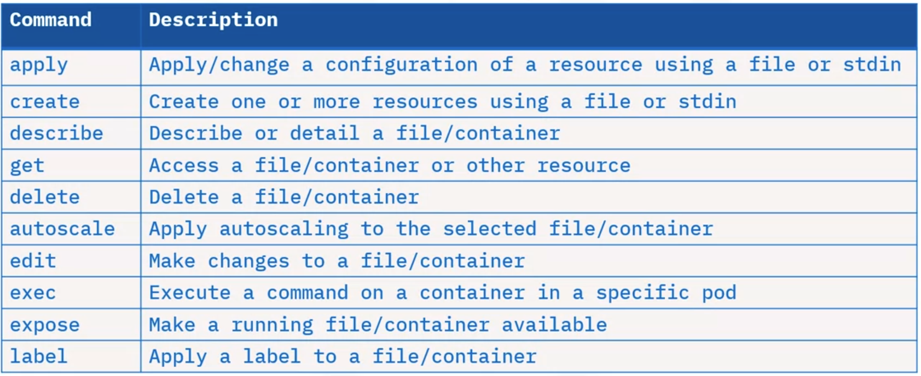
     2. ‘get’ command examples (deal with listing different objects or resources)
        1. Kubectl get services
        2. Kubectl get pods -all-namespaces
        3. Kubectl get deployment my-dep
        4. Kubectl get pods
     3. ‘apply’ command examples (create resources using json or yaml files):
        1. Kubectl apply -f ./my1.yaml -f ./my2.yaml
        2. Kubectl apply -f <https://git.io/bPieo>
     4. ‘scale’ command examples (increases or decreases the number of replicas):
        1. Kubectl scale –replicas=3 rs/foo
        2. Kubectl scale –replicas=3 -f foo.yaml
     5. Crease a resource (cmd + output): Let’s create a deployment with 3 replicas of the nginx image:
        1. 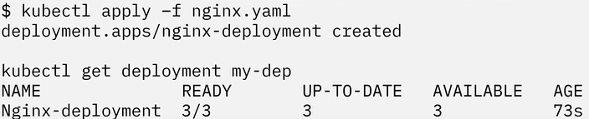

**Docker Cheat Sheet:**

|  |  |
| --- | --- |
| **Command** | **Description** |
| **curl localhost** | Pings the application. |
| **docker build** | Builds an image from a Dockerfile. |
| **docker build . -t** | Builds the image and tags the image id. |
| **docker CLI** | Start the Docker command line interface. |
| **docker container rm** | Removes a container. |
| **docker images** | Lists the images. |
| **docker ps** | Lists the containers. |
| **docker ps -a** | Lists the containers that ran and exited successfully. |
| **docker pull** | Pulls the latest image or repository from a registry. |
| **docker push** | Pushes an image or a repository to a registry. |
| **docker run** | Runs a command in a new container. |
| **docker run -p** | Runs the container by publishing the ports. |
| **docker stop** | Stops one or more running containers. |
| **docker stop $(docker ps -q)** | Stops all running containers. |
| **docker tag** | Creates a tag for a target image that refers to a source image. |
| **docker –version** | Displays the version of the Docker CLI. |
| **exit** | Closes the terminal session. |
| **export MY_NAMESPACE** | Exports a namespace as an environment variable. |
| **git clone** | Clones the git repository that contains the artifacts needed. |
| **ibmcloud cr images** | Lists images in the IBM Cloud Container Registry. |
| **ibmcloud cr login** | Logs your local Docker daemon into IBM Cloud Container Registry. |
| **ibmcloud cr namespaces** | Views the namespaces you have access to. |
| **ibmcloud cr region-set** | Ensures that you are targeting the region appropriate to your cloud account. |
| **ibmcloud target** | Provides information about the account you’re targeting. |
| **ibmcloud version** | Displays the version of the IBM Cloud CLI. |
| **ls** | Lists the contents of this directory to see the artifacts. |

Glossary

|  |  |
| --- | --- |
| **Term** | **Definition** |
| **Agile** | is an iterative approach to project management and software development that helps teams deliver value to their customers faster and with fewer issues. |
| **Client-server architecture** | is a distributed application structure that partitions tasks or workloads between the providers of a resource or service, called servers, and service requesters, called clients. |
| **A container** | powered by the containerization engine, is a standard unit of software that encapsulates the application code, runtime, system tools, system libraries, and settings necessary for programmers to efficiently build, ship and run applications. |
| **Container Registry** | Used for the storage and distribution of named container images. While many features can be built on top of a registry, its most basic functions are to store images and retrieve them. |
| **CI/CD pipelines** | A continuous integration and continuous deployment (CI/CD) pipeline is a series of steps that must be performed in order to deliver a new version of software. CI/CD pipelines are a practice focused on improving software delivery throughout the software development life cycle via automation. |
| **Cloud native** | A cloud-native application is a program that is designed for a cloud computing architecture. These applications are run and hosted in the cloud and are designed to capitalize on the inherent characteristics of a cloud computing software delivery model. |
| **Daemon-less** | A container runtime that does not run any specific program (daemon) to create objects, such as images, containers, networks, and volumes. |
| **DevOps** | is a set of practices, tools, and a cultural philosophy that automate and integrate the processes between software development and IT teams. |
| **Docker** | An open container platform for developing, shipping and running applications in containers. |
| **A Dockerfile** | is a text document that contains all the commands you would normally execute manually in order to build a Docker image. Docker can build images automatically by reading the instructions from a Dockerfile. |
| **Docker client** | is the primary way that many Docker users interact with Docker. When you use commands such as docker run, the client sends these commands to dockerd, which carries them out. The docker command uses the Docker API. The Docker client can communicate with more than one daemon. |
| **Docker Command Line Interface (CLI)** | The Docker client provides a command line interface (CLI) that allows you to issue build, run, and stop application commands to a Docker daemon. |
| **Docker daemon (dockerd)** | creates and manages Docker objects, such as images, containers, networks, and volumes. |
| **Docker Hub** | is the world's easiest way to create, manage, and deliver your team's container applications. |
| **Docker localhost** | Docker provides a host network which lets containers share your host’s networking stack. This approach means that a localhost in a container resolves to the physical host, instead of the container itself. |
| **Docker remote host** | A remote Docker host is a machine, inside or outside our local network which is running a Docker Engine and has ports exposed for querying the Engine API. |
| **Docker networks** | help isolate container communications. |
| **Docker plugins** | such as a storage plugin, provides the ability to connect external storage platforms. |
| **Docker storage** | uses volumes and bind mounts to persist data even after a running container is stopped. |
| **LXC** | LinuX Containers is a OS-level virtualization technology that allows creation and running of multiple isolated Linux virtual environments (VE) on a single control host. |
| **IBM Cloud Container Registry** | stores and distributes container images in a fully managed private registry. |
| **Image** | An immutable file that contains the source code, libraries, and dependencies that are necessary for an application to run. Images are templates or blueprints for a container. |
| **Immutability** | Images are read-only; if you change an image, you create a new image. |
| **Microservices** | are a cloud-native architectural approach in which a single application contains many loosely coupled and independently deployable smaller components or services. |
| **Namespace** | A Linux namespace is a Linux kernel feature that isolates and virtualizes system resources. Processes which are restricted to a namespace can only interact with resources or processes that are part of the same namespace. Namespaces are an important part of Docker’s isolation model. Namespaces exist for each type of resource, including networking, storage, processes, hostname control and others. |
| **Operating System Virtualization** | OS-level virtualization is an operating system paradigm in which the kernel allows the existence of multiple isolated user space instances, called containers, zones, virtual private servers, partitions, virtual environments, virtual kernels, or jails. |
| **Private Registry** | Restricts access to images so that only authorized users can view and use them. |
| **REST API** | A REST API (also known as RESTful API) is an application programming interface (API or web API) that conforms to the constraints of REST architectural style and allows for interaction with RESTful web services. |
| **Registry** | is a hosted service containing repositories of images which responds to the Registry API. |
| **Repository** | is a set of Docker images. A repository can be shared by pushing it to a registry server. The different images in the repository can be labelled using tags. |
| **Server Virtualization** | Server virtualization is the process of dividing a physical server into multiple unique and isolated virtual servers by means of a software application. Each virtual server can run its own operating systems independently. |
| **Serverless** | is a cloud-native development model that allows developers to build and run applications without having to manage servers. |
| **Tag** | A tag is a label applied to a Docker image in a repository. Tags are how various images in a repository are distinguished from each other. |